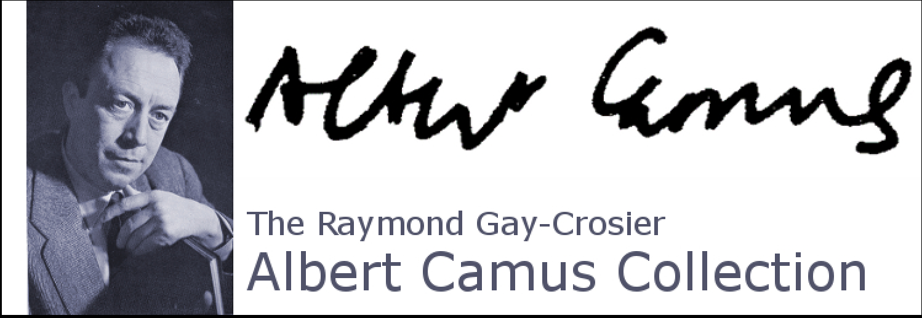

About the Collector, Raymond Gay-Crosier

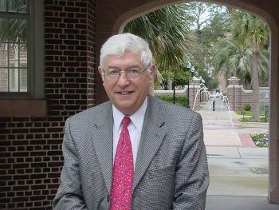
Professional career
Born in Basel, Switzerland, on August 30, 1937, Raymond Gay-Crosier studied at the Universities of Basel, Paris (Sorbonne) and Bern, Switzerland, where he received, in 1965, his doctorat-ès-lettres with a dissertation on Albert Camus's theater. His degree covered French literature (main field), Romance Philology and Philosophy (secondary fields). After having taught French and Philosophy for four years at the Gymnasium Burgdorf (near Bern), he obtained, in 1966, a position as Assistant Professor of French at Trent University (Peterborough, Ont., Canada). The
University of Florida hired him as an Associate Professor in 1967 to cover primarily the field of 20th-century French literature. He served as Graduate Coordinator of French from 1970 to 1981 and was promoted to Full Professor in 1973. Between 1981 and 1993 he was elected to four terms as Chair of the Department of Romance Languages and Literatures. On and off campus he occupied numerous administrative and professional positions, including as President of the South Atlantic Modern Language Association (1992-1994). In 2003, he retired as Professor Emeritus in order to devote all his time to the contributions and direction of the projected four-volume Pléiade edition of Camus's Œuvres complètes (see below).

Publications
Of the approximately 130 sole-authored articles and chapters in books in French, English or German, published in national and international scholarly journals, about half are devoted to Camus while the others are dealing with theory of irony, Mallarmé, Gide, Sartre, Butor, Robbe-Grillet and, especially, Claude Simon. Gay-Crosier is the sole author of the following books: Les Envers d'un échec. Étude sur le théâtre d'Albert Camus (Paris: Lettres Modernes, 1967, re-ed. in paperback series Poche Érudition, Paris: Minard, 1983); Religious Elements in the Secular Lyrics of the Troubadours (Chapel Hill: North Carolina University Press, 1971);

Paradigmes de l'ironie - révolte et affirmation négative (Toronto: Paratexte, 2000); Literary Masterpieces : The Stranger (Detroit: Gale Research, 2002). He is a contributing editor of volumes I and II, editor-in-chief and contributor of volumes III and IV of the critical edition of Albert Camus's Œuvres complètes (Paris: Gallimard, Collection de la Pléiade, 2006 and 2008 respectively). For the centenary of Camus's birth in 2013, he was invited to direct, in the Cahiers de L'Herne series on major authors, an extensive issue for which he solicited the help of Agnès Spiquel as on-location co-director. The Cahier de L'Herne Albert Camus features articles and testimonies by a most representative cross-section of personal friends and specialists of Camus and an array of documents and illustrations. Other significant editorial responsibilities include: editor-in-chief of 12 volumes in the Albert Camus series (Paris, Revue des Lettres Modernes, 1989-2009); founding editor of 10 volumes of the Ars Interpretandi series (Munich/New York, Peter Lang); assistant editor of the French Review (1989-2012). In 1990 he created and maintained until 2012 a comprehensive online Critical Bibliography on Albert Camus presenting thematically and updating regularly all significant books and articles devoted to the author. According to a counter, this bibliography has been consulted by several hundred thousand users. Lists and references to his works can be found on Google and Amazon. He has been a reviewer of numerous manuscripts submitted by scholars to several University and commercial presses.

Conference organizations and participations, visiting stints, keynote lectures
As organizer of the first international symposium on Camus held in 1970 at the University of Florida, he followed up, in 1980, with a much larger second international conference. The proceedings of both events were published as Albert Camus 1970 (Sherbrooke [Canada], CELEF, 1970) and as Camus 1980 (Gainesville, University Presses of Florida, 1980). In 1982, in conjunction with Jacqueline Lévi-Valensi, he organized, by invitation, a décade (a ten-day conference) in the castle of Cerisy-la Salle (France) attracting approximately 100 international scholars. The proceedings were published under the title Albert Camus: œuvre fermée, œuvre ouverte? (Paris: Gallimard, 1984). In almost any given year since the beginning of his career, he participated actively in professional conferences held on various American campuses or by the MLA or SAMLA. In 1996, at the Université de Picardie Jules Verne in Amiens, he held a visiting professorship for a summer semester. Several national and international institutions invited him as a keynote or guest speaker: the Universities of Oslo, Odense, Uppsala (1994), Washington & Lee, Beauvais (1996), the Mishkonot Center for Mediterranean Studies, Jerusalem (1997), Cornell University, Center for European Studies (2002), the University of Ulster at Corelaine (2002 and 2005), the Universities of North Carolina, Greensboro, São Paulo (delegated by French government), the Harvard Humanities Center (2004), the U. of Wisconsin (2006), the Université du Littéral, Dunquerque, Universitat Pompeu Fabra, Barcelona (2007), the Royal Military College of Canada (2009), the New York University, the Florida State University, Université catholique de l'Ouest (Angers), the Dokkyo University, Tokyo (2010), the Universität Zürich, the Boise State University, the Cerisy-la-Salle conference center (2013).

Honors and awards
  - Chevalier (1987) and Officier (1993) des Palmes Académiques (French Government)
  - Honorary Phi Kappa Phi member (1986-)
  - President of the Howe Society (University of Florida, 1994-96)
  - Recipient of various research (Trent University, University of Florida) and travel grants (American Council of Learned Societies, University of Florida)
  - University of Florida President's Scholar (1977-78)

Professional Excellence Award (University of Florida, 1996)
Member of the Chinard Prize Jury (Institut Français de Washington, 1981-1990) and the MLA William Riley Parker Prize Jury (1984-87)
Founding Vice President of the Société des Études Camusiennes/Camus Studies Association and Coordinator of the American branch of the Camus Studies Association (1982-2012)
For the academic year 2000-2001 he was awarded the Delton F. Scudder Term Professorship
In May of 2003, the University of Florida awarded him the title Professor Emeritus

